**SIMATS SCHOOL OF ENGINEERING**

**SAVEETHA INSTITUTE OF MEDICAL AND TECHNICAL SCIENCES CHENNAI-602105**

# E-Voting System

**A CAPSTONE PROJECT REPORT**

*Submitted in the partial fulfillment for the completion of the course*

**CSA4309 INTERNET PROGRAMMING FOR WEB SERVICES**

**IN**

**COMPUTER SCIENCE AND ENGINEERING**

**Submitted by**

**<Y.Rajesh Kumar Reddy> (192211902)**

**<A.Vishnu Vardhan Reddy> (192211909)**

**Under the Supervision of Dr. K.Jayasakthi Velmurugan**

**NOV 2024**

## DECLARATION

We, **Y.Rajesh Kumar Reddy, A.Vishnu Vardhan Reddy**, students of **Bachelor of Engineering in Computer Science**, Department of Computer Science and Engineering, Saveetha Institute of Medical and Technical Sciences, Saveetha

University, Chennai, hereby declare that the work presented in this Capstone Project Work entitled **E- Voting** is the outcome of our own bonafide work and is correct to the best of our knowledge and this work has been undertaken taking care of Engineering Ethics.

(Y.Rajesh Kumar Reddy 192211902),

(A.Vishnu Vardhan Reddy 192211909)

Date: 12/11/2024

Place: chennai

## CERTIFICATE

This is to certify that the project entitled **“E-Voting System”** submitted by **Y.Rajesh Kumar Reddy, A.Vishnu Vardhan Reddy** has been carried out under my supervision. The project has been submitted as per the requirements in the current semester of B. Tech Information Technology.

Supervisor

Dr. K.Jayasakthi Velmurugan

# Table of Contents

|  |  |  |
| --- | --- | --- |
| **S.NO** | **TOPICS** | **PAGE NO** |
| 1 | **Abstract** | 5 |
| 2 | **Introduction** | 6 |
| 3 | **Project Description**  About your project | 7 |
| 4 | **Problem Description**  Program to build a webpage | 8 |
| 5 | **Tool Description**  User interface  Features | 9 |
| 6 | **Operations** | 10 |
| 7 | **Approach / Module Description / Functionalities** | 11 |
| 8 | **Implementation** Coding | 12 |
| 9 | **Output**  Output with Screenshots | 21 |
| 10 | **Conclusion**  Future Enhancement  **References** | 23 |

## ABSTRACT

This report presents the development and implementation of an electronic voting (e-voting) system aimed at revolutionizing the traditional voting process. The primary objective of the e-voting system is to provide a secure, efficient, and user-friendly platform for voters to cast their ballots electronically. Key features of the system include voter authentication, vote anonymity, and real-time result tallying.

Advanced encryption techniques and secure communication protocols are employed to ensure the integrity and security of the voting process, preventing fraud and unauthorized access. The system's adaptability for various types of elections, including governmental, corporate, and organizational, makes it a versatile solution for contemporary voting needs. This report covers the system's design, architecture, implementation, and testing, addressing the challenges encountered and solutions applied. The findings indicate that the e-voting system significantly enhances the accessibility, efficiency, and security of the voting process, with the potential to increase voter participation and confidence in the electoral process.

## INTRODUCTION

Voting is a cornerstone of democratic processes, providing citizens with the means to influence government and organizational decisions. Traditional paper-based voting systems, while established, have numerous drawbacks including logistical challenges, high costs, and potential security vulnerabilities. In response to these challenges, electronic voting (e-voting) systems have emerged as a modern alternative.

E-voting systems offer numerous advantages, such as increased accessibility, reduced costs, and enhanced security. By enabling voters to cast their ballots electronically, these systems can simplify the voting process, making it more convenient and efficient. Additionally, evoting systems can provide faster vote counting and result dissemination, thereby improving the overall efficiency of the electoral process.

This report explores the development of an e-voting system designed to address the shortcomings of traditional voting methods. It covers the system's objectives, design, and implementation, and provides a comprehensive analysis of its performance and security.

**PROJECT DESCRIPTION**

## About The Project

The e-voting system project aims to create a secure and efficient platform for conducting elections electronically. The system is designed to be user-friendly, ensuring that voters of all technical skill levels can navigate it with ease. The primary components of the system include voter registration, ballot casting, and result tallying. Each of these components is built with robust security measures to protect against fraud and unauthorized access.

The voter registration component ensures that only eligible voters can participate in the election. Voter authentication is achieved through a combination of personal identification numbers (PINs) and biometric verification, such as fingerprint or facial recognition. This dual-layer authentication process enhances the security of the system, ensuring that only authorized individuals can cast their ballots.

The ballot casting component allows voters to select their preferred candidates or options in a secure and anonymous manner. Votes are encrypted and stored in a secure database, preventing tampering and ensuring voter anonymity. The system is designed to be intuitive, with clear instructions and a straightforward interface to guide voters through the process.

The result tallying component provides real-time updates on the voting process, allowing election officials to monitor participation and results as they come in. The system uses advanced algorithms to ensure accurate and efficient vote counting, with built-in safeguards to detect and prevent irregularities.

**PROJECT DESCRIPTION: USER INTERFACE AND FEATURES**

## User Interface

The user interface (UI) of the e-voting system is designed to be simple and intuitive, ensuring a smooth experience for voters. The main elements of the UI include the login screen, the voting screen, and the confirmation screen.

* **Login Screen:** The login screen is the entry point for voters. It prompts users to enter their voter ID and PIN, followed by biometric verification if enabled. The design is clean and uncluttered, with clear instructions to guide users through the authentication process.
* **Voting Screen:** Once authenticated, voters are directed to the voting screen. Here, they can view the list of candidates or options available for selection. Each option is presented with a brief description and a corresponding checkbox or radio button. The layout is designed to minimize confusion and ensure that voters can make their selections easily.
* **Confirmation Screen:** After making their selections, voters are taken to the confirmation screen. This screen displays a summary of their choices and asks them to confirm their vote. Voters can either confirm their selections or go back to make changes. This step ensures that voters have the opportunity to review their choices before final submission.

## Features

The e-voting system boasts a range of features designed to enhance security, accessibility, and efficiency:

* **Voter Authentication:** A dual-layer authentication process using PINs and biometric verification ensures that only eligible voters can participate.
* **Vote Anonymity:** Votes are encrypted and stored securely, maintaining voter anonymity and preventing tampering.
* **Real-Time Tallying:** The system provides real-time updates on the voting process and results, allowing for efficient monitoring and swift result dissemination.
* **Accessibility:** The system is designed to be accessible to all voters, including those with disabilities. Features such as screen readers, adjustable text sizes, and highcontrast modes are included to accommodate various needs.
* **User-Friendly Interface:** The intuitive design of the UI ensures that voters can navigate the system with ease, reducing the likelihood of errors and enhancing the overall voting experience.
* **Security Measures:** Advanced encryption techniques and secure communication protocols are employed to safeguard the voting process against fraud and unauthorized access.
* **Scalability:** The system is scalable and can be adapted for various types of elections, from small organizational votes to large-scale governmental elections.

## OPERATIONS

The e-voting system performs the following operations:

1. **Voter Registration:** Allows users to register for the voting system by providing necessary personal details and verifying their identity.
2. **Voter Authentication:** Authenticates registered voters using secure methods such as passwords, PINs, or biometric data.
3. **Ballot Presentation:** Presents the ballot to authenticated voters, displaying candidates or options clearly.
4. **Vote Casting:** Enables voters to cast their votes securely and ensures that each vote is recorded anonymously.
5. **Vote Encryption:** Encrypts the cast votes to protect their integrity and ensure anonymity.
6. **Vote Tallying:** Counts the encrypted votes in real-time and updates the results as the election progresses.
7. **Result Display:** Displays the final election results once voting is complete and votes are tallied.
8. **Audit Logging:** Logs all actions and transactions for auditing purposes to ensure transparency and accountability.

### APPROACH / MODULE DESCRIPTION / FUNCTIONALITIES

The e-voting system is designed with modularity in mind, allowing for each functionality to be developed, tested, and maintained independently. The key modules and their functionalities are as follows:

1. **User Registration Module** o **Function:** Handles the registration of new users, capturing personal details and verifying their identity.
   * **Operations:** Collects and stores voter information, generates unique voter IDs.
2. **Authentication Module** o **Function:** Verifies the identity of registered voters. o **Operations:** Authenticates users via passwords, PINs, or biometric data, and grants access to the voting system.
3. **Voting Module** o **Function:** Manages the voting process, from presenting the ballot to casting the vote.
   * **Operations:** Displays candidates/options, accepts voter selections, encrypts and stores votes.
4. **Tallying Module** o **Function:** Counts votes and updates results in real-time. o **Operations:** Decrypts votes, tallies results, detects and reports any irregularities.
5. **Result Display Module** o **Function:** Presents the election results once voting is complete. o **Operations:** Displays real-time updates during voting and final results postvoting.
6. **Security Module** o **Function:** Ensures the integrity and security of the voting process.
   * **Operations:** Encrypts votes, secures data transmission, prevents unauthorized access, and maintains audit logs.

**IMPLEMENTATION**

### Admin.html

<!DOCTYPE html>

<html lang="en">

<head>

<meta charset="utf-8">

<meta http-equiv="X-UA-Compatible" content="IE=edge">

<meta name="viewport" content="width=device-width, initial-scale=1"> <title>Elections 2022</title>

<link href="css/bootstrap.min.css" rel="stylesheet">

<link href='http://fonts.googleapis.com/css?family=Ubuntu' rel='stylesheet' type='text/css'>

<link href='http://fonts.googleapis.com/css?family=Raleway' rel='stylesheet' type='text/css'>

<link href='http://fonts.googleapis.com/css?family=Oswald' rel='stylesheet' type='text/css'>

<link href='http://fonts.googleapis.com/css?family=Roboto+Condensed' rel='stylesheet' type='text/css'>

<style>

body{ margin:0px; padding:0px;

}

.headerFont{

font-family: 'Ubuntu', sans-serif; font-size: 24px;

}

.subFont{

font-family: 'Raleway', sans-serif; font-size: 14px;

}

.specialHead{

font-family: 'Oswald', sans-serif;

}

.normalFont{

font-family: 'Roboto Condensed', sans-serif;

} a {

color: #FFFFFF;

text-decoration: none;

}

a:link { color: #FFFFFF;

text-decoration: none;

}

/* visited link */ a:visited { color: #FFFFFF;

text-decoration: none;

}

/* mouse over link */ a:hover { color: #FFFFFF; text-decoration: none;

}

/* selected link */ a:active { color: #FFFFFF;

text-decoration: none;

}

cen {text-align: center;}

</style>

</head>

<body>

<div class="container">

<nav class="navbar navbar-default navbar-fixed-top navbar-inverse

" role="navigation">

<div class="container">

<button type="button" class="navbar-toggle" data-toggle="collapse" datatarget="#example-nav-collapse"> <span class="icon-bar"></span>

<span class="icon-bar"></span> <span class="icon-bar"></span>

</button>

<div class="navbar-header">

<a href="index.html" class="navbar-brand headerFont text-lg"><strong>E-Voting

2024</strong></a>

</div>

<div class="collapse navbar-collapse" id="example-nav-collapse">

<ul class="nav navbar-nav">

<li><a href="nomination.html"><span

class="subFont"><strong>Candidates</strong></span></a></li>

</ul>

<span class="normalFont"><a href="admin.html" class="btn btn-success navbar-right navbar-btn"><strong>Admin Login</strong></a></span>

</div>

</div>

</nav>

</div>

<div class="container-fluid">

<div class="row">

<div class="col-sm-12">

<div class="jumbotron text-center text-block" style="padding-top:30px;">

<img src="images/MAT.png" alt="">

<h1 class="specialHead"> E-Voting 2024</h1>

<p class="normalFont">Safe . Reliable . Secure . Fast </p>

<a href="vault.html" class="btn btn-primary btn-md specialHead"> <span class="glyphicon glyphicon-tag"></span>Vote Here</a>

</div>

</div>

</div>

</div>

<div class="conatiner" id="featuresTab">

<div class="row">

<div class="col-sm-12 text-center">

<div class="page-header" style="padding-top:50px;padding-bottom:50px">

<h1 class="normalFont" style="font-size:44px;" >WHAT IS 2024 E-Voting System.</h1>

<p class="subFont" style="font-size:24px;">A Intractive Way To Solve

Conventional Voting.</p>

</div>

</div>

</div>

</div>

<div class="conatiner" style="padding:50px;" id="aboutTab">

<div class="row">

<div class="col-sm-4 text-center">

<img src="images/Nominee.png" width="100" height="100" alt=""/>

<a href="vault.html" class="normalFont" style="font-size:28px;"><h2 style="color: black">VOTE ONLINE</h2></a>

<p>You Just Need Basic Details of Yours and We Will Let You Vote.</p>

</div>

<div class="col-sm-4 text-center">

<img src="images/Vote.png" width="100" height="100" alt=""/>

<a href="nomination.html" class="normalFont" style="font-size:28px;"><h2 style="color: black">Nomination</h2></a>

<p>Admin's Control Panel allows you to manage the list of filled nomination.</p> </div>

<div class="col-sm-4 text-center">

<img src="images/Stats.png" width="100" height="100" alt=""/> <h2 class="normalFont" style="font-size:28px;" >Statistics</h2>

<p>Shows You the Graphical Data Representation of your votes. And, It is in

Admin's Control Panel.</p>

</div>

</div>

</div>

<hr>

<footer>

<div class="container">

<div class="row">

<div class="col-sm-6 text-center">

<cen><h4 class="specialHead">Project By<br>Y.Rajesh Kumar Reddy<br>A.Vishnu Vardhan Reddy</h4></cen>

</div>

</div>

</div>

</footer>

<script src="https://ajax.googleapis.com/ajax/libs/jquery/1.11.2/jquery.min.js"></script> <script src="js/bootstrap.min.js"></script>

</body>

</html>

### Index.Html

<!DOCTYPE html>

<html lang="en">

<head>

<meta charset="utf-8">

<meta http-equiv="X-UA-Compatible" content="IE=edge">

<meta name="viewport" content="width=device-width, initial-scale=1">

<!-- The above 3 meta tags *must* come first in the head; any other head content must come *after* these tags --> <title>Admin Panel</title>

<!-- Bootstrap -->

<link href="css/bootstrap.min.css" rel="stylesheet">

<link href='http://fonts.googleapis.com/css?family=Ubuntu' rel='stylesheet' type='text/css'> <link href='http://fonts.googleapis.com/css?family=Raleway' rel='stylesheet' type='text/css'>

<link href='http://fonts.googleapis.com/css?family=Oswald' rel='stylesheet' type='text/css'>

<link href='http://fonts.googleapis.com/css?family=Roboto+Condensed' rel='stylesheet' type='text/css'>

<style> .headerFont{

font-family: 'Ubuntu', sans-serif;

font-size: 24px;

}

.subFont{

font-family: 'Raleway', sans-serif; font-size: 14px;

}

.specialHead{

font-family: 'Oswald', sans-serif;

}

.normalFont{

font-family: 'Roboto Condensed', sans-serif;

}

</style>

<!-- HTML5 shim and Respond.js for IE8 support of HTML5 elements and media queries -->

<!-- WARNING: Respond.js doesn't work if you view the page via file:// --> <!--[if lt IE 9]>

<script src="https://oss.maxcdn.com/html5shiv/3.7.2/html5shiv.min.js"></script> <script src="https://oss.maxcdn.com/respond/1.4.2/respond.min.js"></script> <![endif]-->

</head>

<body>

<div class="container">

<nav class="navbar navbar-default navbar-fixed-top navbar-inverse

" role="navigation">

<div class="container">

<button type="button" class="navbar-toggle" data-toggle="collapse" datatarget="#example-nav-collapse"> <span class="icon-bar"></span>

<span class="icon-bar"></span>

<span class="icon-bar"></span>

</button>

<div class="navbar-header">

<a href="index.html" class="navbar-brand headerFont textlg"><strong>Voting</strong></a>

</div>

<div class="collapse navbar-collapse" id="example-nav-collapse">

<ul class="nav navbar-nav">

<!--

<li><a href="#featuresTab"><span

class="subFont"><strong>Features</strong></span></a></li>

<li><a href="#feedbackTab"><span

class="subFont"><strong>Feedback</strong></span></a></li>

<li><a href="#"><span class="subFont"><strong>About</strong></span></a></li>

-->

</ul>

<button type="submit" class="btn btn-success navbar-right navbar-btn"><span class="normalFont"><strong>Admin Panel</strong></span></button>

</div>

</div> <!-- end of container -->

</nav>

<div class="container" style="padding-top:150px;">

<div class="row">

<div class="col-sm-4"></div>

<div class="col-sm-4" style="border:2px solid gray;padding:50px;">

<div class="page-header">

<h2 class="specialHead">Authentication</h2>

</div>

<form action="authentication.php" method="POST">

<div class="form-group">

<label for="">Username</label><br>

<input type="text" name="adminUserName" placeholder="Enter Admin's UserName" class="form-control"><br>

<label for="">Password</label><br>

<input type="password" name="adminPassword" class="form-control" placeholder="Enter Admin's Password"><br>

<button type="submit" class="btn btn-block span btn-primary "><span class="glyphicon glyphicon-user"></span> Sign In</button>

<label id="error"></label>

</div>

</form>

<br>

</div>

<div class="col-sm-4"></div>

</div>

</div>

</div>

<!-- jQuery (necessary for Bootstrap's JavaScript plugins) -->

<script src="https://ajax.googleapis.com/ajax/libs/jquery/1.11.2/jquery.min.js"></script>

<!-- Include all compiled plugins (below), or include individual files as needed --> <script src="js/bootstrap.min.js"></script>

</body>

</html>

### Savevote.php

<!DOCTYPE html>

<html lang="en">

<head>

<meta charset="utf-8">

<meta http-equiv="X-UA-Compatible" content="IE=edge">

<meta name="viewport" content="width=device-width, initial-scale=1">

<title>SUCCESSFULLY VOTED</title>

<!-- Bootstrap -->

<link href="css/bootstrap.min.css" rel="stylesheet">

<link href='http://fonts.googleapis.com/css?family=Ubuntu' rel='stylesheet' type='text/css'> <link href='http://fonts.googleapis.com/css?family=Raleway' rel='stylesheet' type='text/css'>

<link href='http://fonts.googleapis.com/css?family=Oswald' rel='stylesheet' type='text/css'>

<link href='http://fonts.googleapis.com/css?family=Roboto+Condensed' rel='stylesheet' type='text/css'>

<style>

.headerFont {

font-family: 'Ubuntu', sans-serif; font-size: 24px;

}

.subFont {

font-family: 'Raleway', sans-serif;

font-size: 14px;

}

.specialHead {

font-family: 'Oswald', sans-serif;

}

.normalFont {

font-family: 'Roboto Condensed', sans-serif;

}

</style>

</head>

<body>

<div class="container">

<nav class="navbar navbar-default navbar-fixed-top navbar-inverse" role="navigation"> <div class="container">

<button type="button" class="navbar-toggle" data-toggle="collapse" datatarget="#example-nav-collapse">

<span class="icon-bar"></span>

<span class="icon-bar"></span>

<span class="icon-bar"></span>

</button>

<div class="navbar-header">

<a href="index.html" class="navbar-brand headerFont text-lg"><strong>EVoting 2024</strong></a>

</div>

<div class="collapse navbar-collapse" id="example-nav-collapse"> <ul class="nav navbar-nav"></ul>

<button type="submit" class="btn btn-success navbar-right navbar-btn"><span class="normalFont"><strong>Admin Panel</strong></span></button>

</div>

</div> <!-- end of container -->

</nav>

<div class="container" style="padding-top:150px;">

<div class="row">

<div class="col-sm-4"></div>

<div class="col-sm-4 text-center" style="border:2px solid gray;padding:50px;">

<?php

function test_input($data) {

return htmlspecialchars(stripslashes(trim($data)));

}

if(isset($_POST["submit"])) {

if(isset($_POST["voterName"]) && isset($_POST["voterEmail"]) &&

isset($_POST["voterID"]) && isset($_POST["selectedCandidate"])) {

$name = test_input($_POST["voterName"]);

$email = test_input($_POST["voterEmail"]);

$voterID = test_input($_POST["voterID"]);

$selection = test_input($_POST["selectedCandidate"]);

$DB_HOST = "localhost";

$DB_USER = "root";

$DB_PASSWORD = "";

$DB_NAME = "db_evoting";

$conn = new mysqli($DB_HOST, $DB_USER, $DB_PASSWORD,

$DB_NAME);

if($conn->connect_error) {

die("ERROR: Could not connect. " . $conn->connect_error);

}

$stmt = $conn->prepare("INSERT INTO tbl_users (full_name, email, voter_id, voted_for) VALUES (?, ?, ?, ?)");

$stmt->bind_param("ssis", $name, $email, $voterID, $selection);

if($stmt->execute()) {

echo "<img src='images/success.png' width='70' height='70'>";

echo "<h3 class='text-info specialHead text-center'><strong> YOU'VE

SUCCESSFULLY VOTED.</strong></h3>";

echo "<a href='index.html' class='btn btn-primary'> <span class='glyphicon glyphicon-ok'></span> <strong> Finish</strong> </a>";

} else {

echo "<img src='images/error.png' width='70' height='70'>";

echo "<h3 class='text-info specialHead text-center'><strong> SORRY WE'VE SOME ISSUE..</strong></h3>";

echo "<a href='index.html' class='btn btn-primary'> <span class='glyphicon glyphicon-ok'></span> <strong> Finish</strong> </a>";

}

$stmt->close();

$conn->close();

} else {

echo "<br>All Fields Required";

}

}

?>

</div>

<div class="col-sm-4"></div>

</div>

</div>

</div>

<!-- jQuery (necessary for Bootstrap's JavaScript plugins) -->

<script src="https://ajax.googleapis.com/ajax/libs/jquery/1.11.2/jquery.min.js"></script>

<!-- Include all compiled plugins (below), or include individual files as needed --> <script src="js/bootstrap.min.js"></script>

</body>

</html>

**OUTPUTS:**

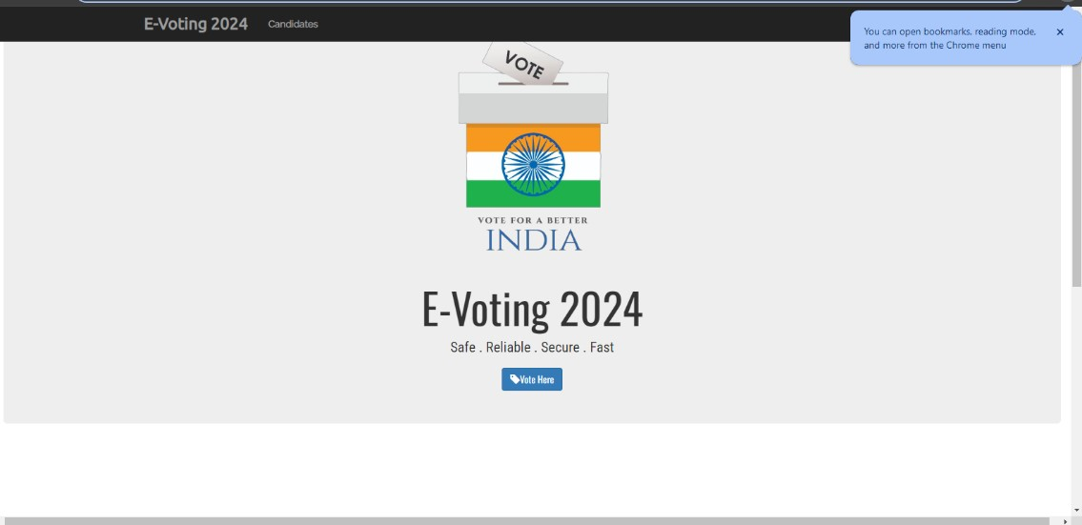

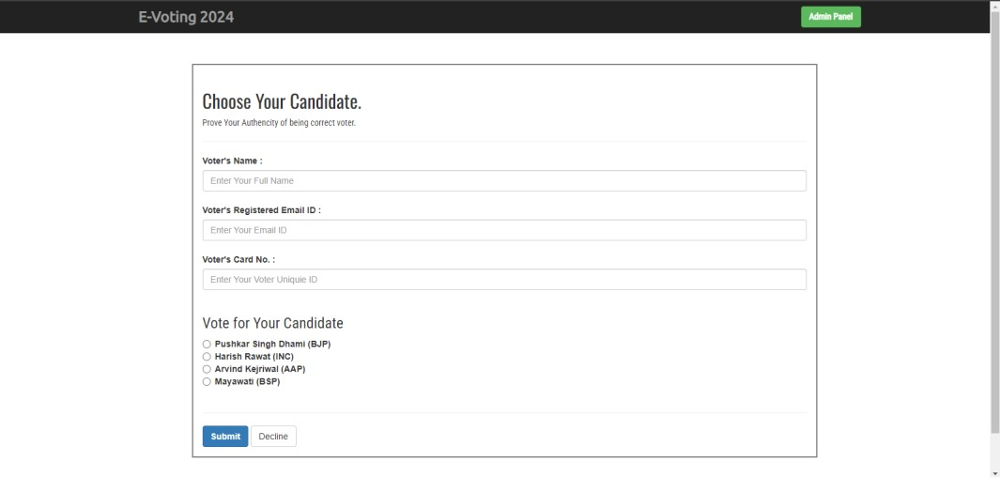

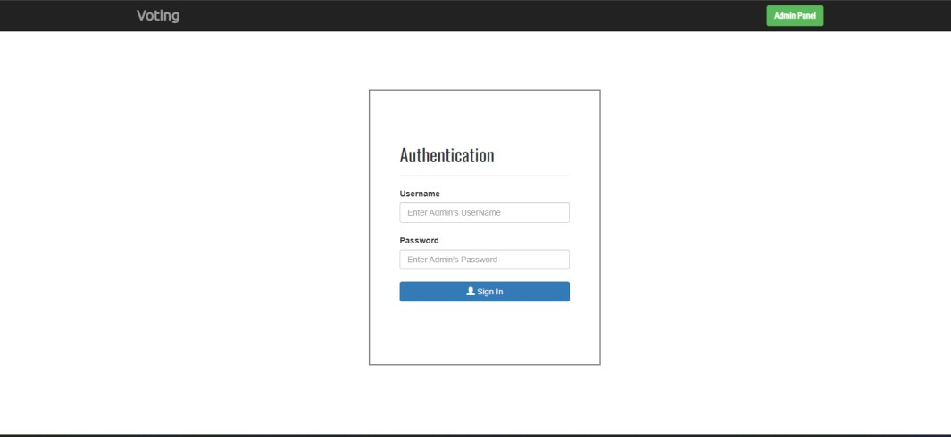

### CONCLUSION

The e-voting system represents a significant advancement in the way elections are conducted. By leveraging modern technology, it addresses the limitations of traditional voting methods, offering a secure, efficient, and user-friendly alternative. This project not only enhances the voting experience but also contributes to the integrity and reliability of the electoral process, ultimately fostering greater voter confidence and participation.

### FUTURE ENHANCEMENT

Future enhancements for the e-voting system could include:

1. **Web-Based Interface:** Developing a web-based interface to allow for remote access and management of the voting system.
2. **Integration with Government Databases:** Integrating the e-voting system with government databases for real-time verification of voter eligibility.
3. **Advanced Security Measures:** Implementing more advanced security measures such as blockchain technology to further enhance vote integrity.
4. **Mobile Application:** Creating a mobile application to enable voters to cast their votes securely from their smartphones.
5. **Detailed Analytics:** Adding analytics features to provide insights into voter turnout and patterns, which can help improve future elections.

### REFERENCES

* Flask Web Development: Developing Web Applications with Python by Miguel Grinberg.
* JavaScript: The Definitive Guide by David Flanagan
* Mastering Web Application Development with AngularJS by Pawel Kozlowski and Peter Bacon Darwin
* CSS: The Missing Manual by David Sawyer McFarland
* Node.js Design Patterns: Design and Implement Production-Grade Node.js Applications Using Proven Patterns and Techniques by Mario Casciaro and Luciano Mammino